1. **Personal Brand /Information**

* Ayanda Dimpho Booi
* About: A dynamic professional equipped with a wealth of experience and expertise cultivated throughout an extensive learning journey. Specialized in network security, ICSCADA fundamentals, ITIL v4, and IAM practices. Actively seeking opportunities to contribute skills and gain practical experience in various industries. Proficient in tools such as Nmap and Wireshark, with a strong emphasis on effective communication, both written and verbal. Demonstrates a goal-oriented, solution-focused approach, coupled with resilience and a collaborative team spirit.
* 
* IT Support Engineer |Cybersecurity Analyst | Network Engineer
* booi.avd@gmail.com | (+27)67 008 6351

**2. Website Objectives**

* Career Growth

**3.Design Preferences**

* 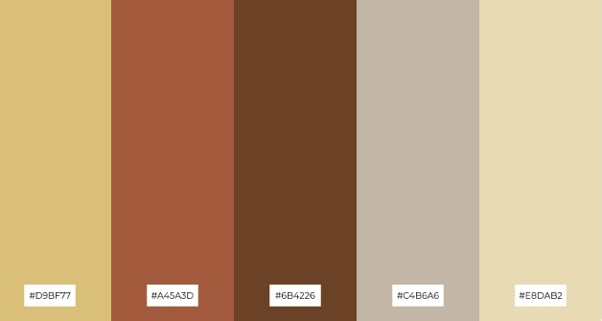

Please use these colours

**4.Portfolio Content**

* **Skills / Expertise:**

ICS Networking Devices and Architectures Time Management

Security Practices Implementation

Risk Analysis in IT and Corporate Networks

Intrusion and Malware Analysis

Network Security Design

NIST Cybersecurity Framework

Kali Linux

Web Development (HTML, CSS, JavaScript,PHP)

Active Directory Domain

Linux Administration

* **Certifications/Badges:**

Certificate Course –CCNA,2025

Certificate Course - Technical Support (MICT Seta),2024

Certificate Course – Yeastar Certified Technician,2024

Certificate Course- Network Security, 2023

Certificate Course – Industrial Control System, 2023

Certificate Course – ICS /SCADA Security Fundamentals, 2023

Certificate Course – ICS/SCADA Cybersecurity, 2023

Certificate Course - ICS/SCADA Security Analyst,2023

Certificate Course – Networking Basics, 2023

Certificate Course – Networking Devices and Initial Configuration, 2023

Certificate Course – Cyberthreat Management, 2023

Certificate Course – CompTIA Linux, 2023

Certificate Course – Windows Operating System, 2023

Certificate Course – Identity and Access Management, 2023

Certificate Course – ITIL 4 foundation, 2023

Cisco Jnr Cybersecurity Analyst, 2023

* **Tools /Technologies:** Nmap,Wireshark , Burpsuite, Splunk and Metasploit
* **Projects**

**Privacy Preservation and Perimeter Protection**

* Explored vulnerabilities and network architecture in the water and wastewater industry.

**Doomsday in a Mega Automobile Factory**

* **Investigated and simulated** catastrophic events in an automobile factory.

**Endpoint Security**

* Secured various network endpoints against cyber-attacks.

**5.Social Media**

* **Linkedin:** https://www.linkedin.com/in/ayanda-booi/